**1.2 I can assess the suitability of development environments for given projects.**

For a large or physical project such as for a building of some kind, the waterfall methodology is suitable. This is because it makes sense to spend time creating a plan and have steps that follow one another.

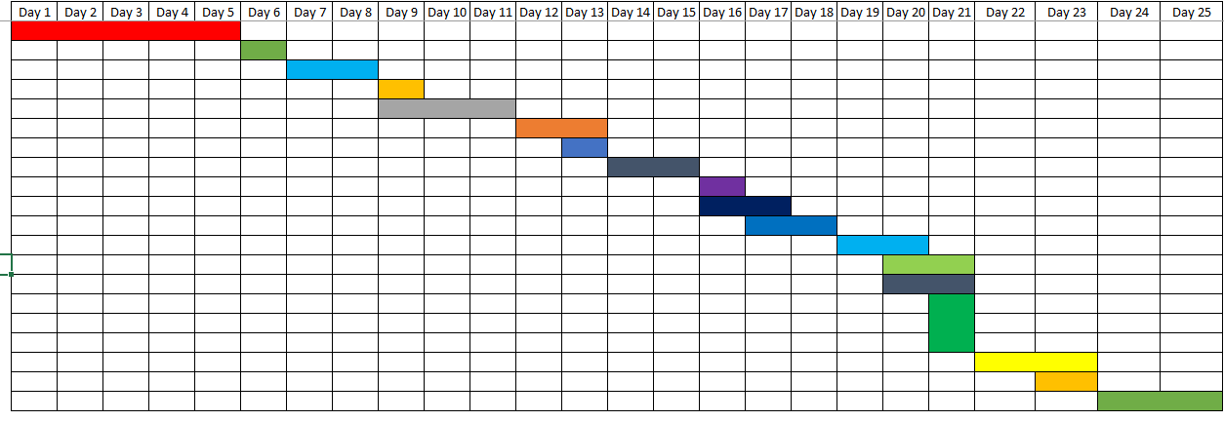

However, for software development it may mean that the customer/ product owner doesn’t see their software until a late stage in the process, and should complications be discovered at that point it can be costly to fix.

Because of the unsuitability for software creation, the Agile methodology was created. Much more suited to intangible technology-based projects, Agile allows a team to respond to change much more easily and quickly.

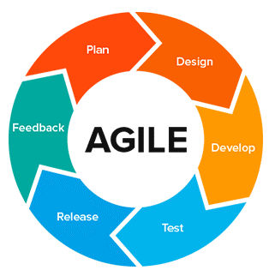

*Image taken from https://www.wearemarketing.com*

There are a number of Agile methodologies that have since been developed, some of the more popular being Scrum, extreme programming, and Kanban.

**Scrum**

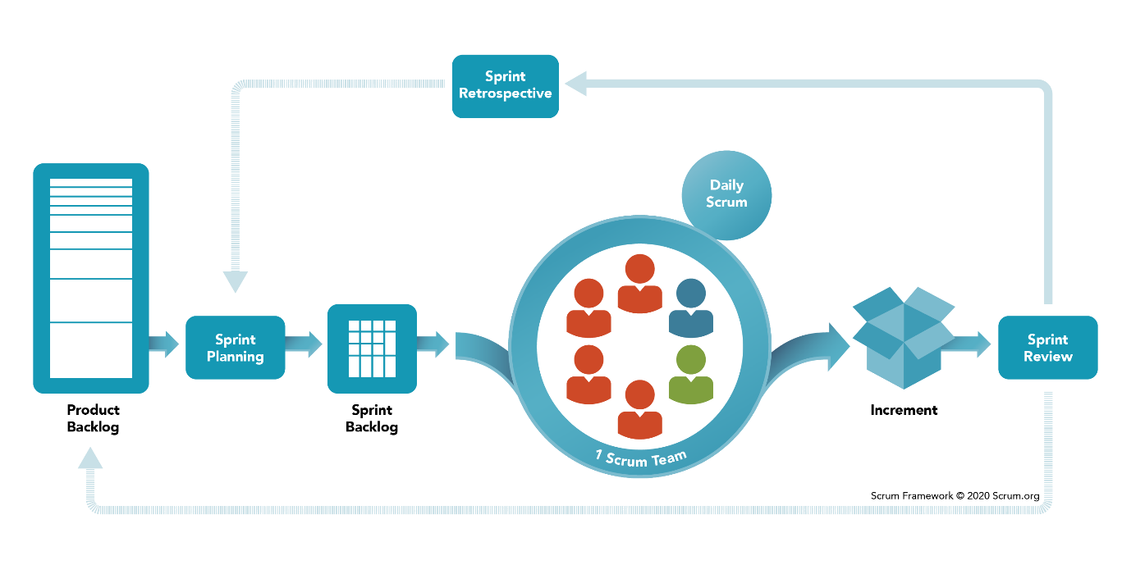

*Image taken from https://www.scrum.org*

With scrum, the product owner has a team of developers who nominate a scrum master. A backlog of tasks to resolve are generated, and the developer teams bid for the work to do. These tasks are completed in what are called *sprints*, with new sprints starting as soon as the previous finished. Regular meetings and learning from feedback enable early versions of the software to be presented to the product owner until a resolution, or the project is cancelled.

**Extreme programming**

With extreme programming, speed and continuous delivery is prioritised. Testing is often done simultaneously whilst the software is being developed, and iterations of the software is presented to the customer every one to three weeks. Continuous planning and close teamwork contribute towards the goal of improving the quality of software and the responsiveness to changes made by the customer.

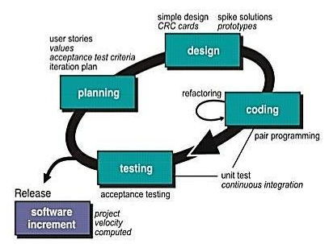

*Image taken from https://www.researchgate.net*

**Kanban**

Kanban is a visual to-do list which teams can use to see clearly what tasks are to do, are being done, and have been completed. Similar the scrum method, continuous collaboration is encouraged, in a bid to improve the flow of work.

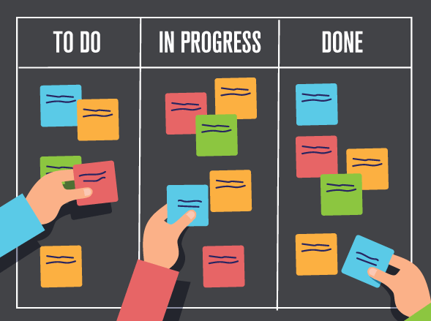

*Image taken from https://www.integrify.com/blog/posts/kanban-project-management/*